* Copy từ CreateListing.jsx

* Xử lý lỗi hình trên

* Xử lý lỗi trên

* Do chưa khai báo ref

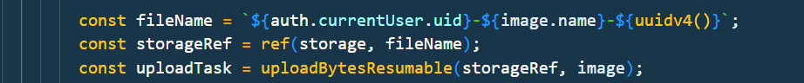

Xử lý nếu không phải là người đăng thì không thể sửa nó

* Kiểm tra xem ai đang chỉnh sửa



* Xử lý lỗi trên bởi vì listing là []

